On January 1, 2019 changes to the mandated reporter requirements, as passed by the Illinois General Assembly, went into effect. Candidates who are being fingerprinted to be added to the ROE #30 substitute list must complete the mandated reporter training and bring in the certificate of completion before that person will be added to the substitute list. The web address for the training is: https://mr.dcfstraining.org/UserAuth/Login!loginPage.action. Candidates will need to create and account by going to the DCFS webpage (listed above) and clicking on the green button on the top right side of the page. Candidates will then need to follow the prompts and complete the final registration page with the following information.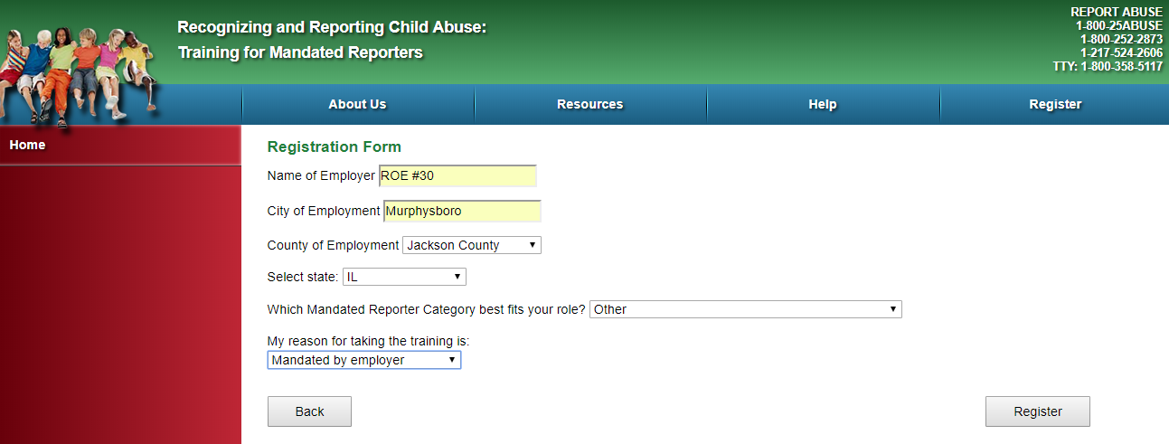
The training will take a minimum of 30 minutes. During the training, you will be prompted to complete and print a mandated reporters signature page, which must be signed and submitted to ROE #30 along with the certificate of completion that you will be allowed to print at the end of the training process.

